MA4605 Lab E (Week 6)

Part 1 - Weighted Linear Regression

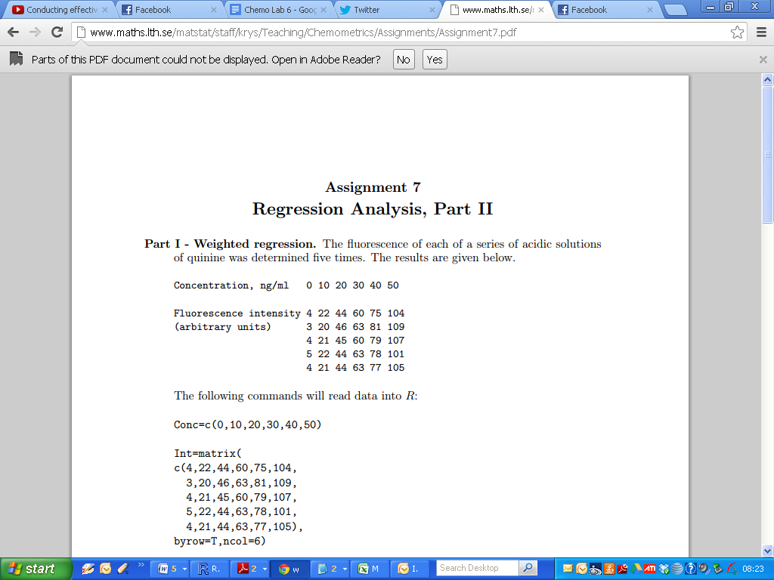

Compute the average value and standard deviation for Fluorescence at each level of concentration.

|  |
| --- |
| Fluo.Matrix = matrix( c(4,22,44,60,75,104, 3,20,46,63,81,109, 4,21,45,60,79,107, 5,22,44,63,78,101, 4,21,44,63,77,105), byrow=T,ncol=6)  apply(Fluo.Matrix,2,mean)  apply(Fluo.Matrix,2,sd) |

Comment on the standard deviations. Are the variance values uniform (roughly the same level) ? Write your answer in the submission sheet.  
  
Using the following R code, fit a linear model for this data (i.e. mean values of “Fluo” v “Conc”). Write out the regression equation in your submission sheet. Comment on the significance of each estimate (mentioning the numbers of asterisks beside each coefficient will suffice).

|  |
| --- |
| Fluo.Mean = apply(Fluo.Matrix,2,mean) Conc=c(0,10,20,30,40,50)  Fit1 = lm(Fluo.Mean ~ Conc) summary(Fit1) |

Repeat the regression model fitting procedure using each individual observation of Fluoresence. Write down the regression equation. Comment on the significance of each regression coefficient. Also sketch the scatter-plot.

|  |
| --- |
| Conc=c(0,10,20,30,40,50) Conc.M=rep(Conc,5)  Fluo.M=c(4,22,44,60,75,104, 3,20,46,63,81,109, 4,21,45,60,79,107, 5,22,44,63,78,101, 4,21,44,63,77,105) |

|  |
| --- |
| Fit2 = lm(Fluo.M ~ Conc.M) summary(Fit2)  plot(Conc.M,Fluo.M,pch=18,col="red") abline(coef(Fit2)) |

Perform a weighting linear regression model using the following code.

|  |
| --- |
| Fluo.mean =apply(Fluo.Matrix,2,mean)  Fluo.sd = apply(Fluo.Matrix,2,sd)  weights=Fluo.sd^(-2)/mean(Fluo.sd^(-2))  FitC = lm(Fluo.mean~Conc , weights=weights) |

Write down the regression equation. Comment on the significance of each regression coefficient.

**Part 2- Quadratic and Cubic Relationships**  
  
In an experiment to determine hydrolysable tannins in plants by absorption spectroscopy the following results were obtained:

|  |
| --- |
| Abso= c(0.084, 0.183, 0.326, 0.464, 0.643, 0.707, 0.717, 0.734 ,0.749) Conc= c(0.123, 0.288, 0.562, 0.921, 1.420, 1.717, 1.921, 2.137 ,2.321)  plot(Conc,Abso,pch=18,col="red")  # Generate powers of independent variable - Conc  Conc.squared = Conc^2 Conc.squared  Conc.cubed = Conc^3 Conc.cubed |

Polynomial regression is similar to Multiple Linear Regression - the various independent variables are simply powers of an underlying variable. Polynomial regression is useful for curvilinear relationships between variables.  
  
On your submission sheet, draw a sketch of the scatter-plot. Comment on the shape of the scatter-plot? Is the relationship linear? Is there curvature present?

For the quadratic and cubic models, the regression equations have the following form.

y dependent variable  
x underlying independent variable    
bi regression coefficients

Linear : y = b0 + b1 x   
Quadratic : y = b0 + b1 x + b2 x2  
Cubic: y = b0 + b1 x + b2 x2+ b3 x3

|  |
| --- |
| FitA = lm(Abso~Conc) FitB = lm(Abso~Conc + Conc.squared) FitC = lm(Abso~Conc + Conc.squared + Conc.cubed) |

Using the summary command, write out the regression equation for each of these three models.

The number of asterisks beside the p-value indicates the level of significance of the estimates. How many asterisks beside each estimate?  
  
  
We can remove the intercept term from the model by additionally specifying “-1” in the R code, which specifies to fit a model without an intercept.

(We shall apply it to quadratic and cubic model only)

y=b1 x + b2 x2  
y=b1 x + b2 x2+ b3 x3

|  |
| --- |
| FitD = lm(Abso~Conc + Conc.squared-1) FitE = lm(Abso~Conc + Conc.squared + Conc.cubed-1) |

Does removing the intercept improve the model fit? Examine the R-squared values in the summary fit? Discuss?